RESOLUTION NO.__________

RE: CERTIFICATE OF APPROPRIATENESS UNDER THE
PROVISIONS OF THE ACT OF THE PENNSYLVANIA
LEGISLATURE 1961, JUNE 13, P.L. 282 (53
SECTION 8004) AND BETHLEHEM ORDINANCE NO.
3952 AS AMENDED.

WHEREAS, it is proposed to install approximately twenty-five storm windows at 402 High St.

NOW, THEREFORE, BE IT RESOLVED by the Council of the City of Bethlehem that a Certificate of Appropriateness is hereby granted for the proposal.

Sponsored by: (s)

(s)

ADOPTED BY COUNCIL THIS DAY OF

(s)
President of Council

ATTEST:

(s)
City Clerk

HISTORICAL & ARCHITECTURAL REVIEW BOARD

The applicant is proposing to install approximately twenty-five storm windows at 402 High St.
APPLICATION #3:

Michael & Amy Santanasto
402 High St.
Bethlehem, PA 18018

OWNER:

__________________________________________________________________________

The Board upon motion by Gen Marcon and seconded by Marsha Fritz adopted the proposal that City Council issue a Certificate of Appropriateness for the following:

- Installation of twenty-five aluminum storm windows.

- Windows to be factory finished in Primrose Yellow.

3. The motion was unanimously approved.
__________________________________________________________________________

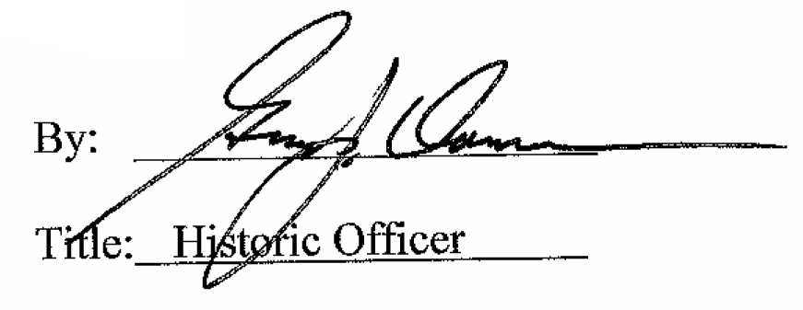

Date of Meeting: January 4, 2017

